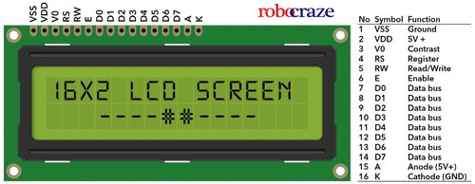

Pinout
• 8 data pins D7:D0
Bi-directional data/command pins.
Alphanumeric characters are sent in ASCII format.
• RS: Register Select
RS = 0 -> Command Register is selected
RS = 1 -> Data Register is selected
• R/W: Read or Write
0 -> Write, 1 -> Read
• E: Enable (Latch data)
Used to latch the data present on the data pins.
A high-to-low edge is needed to latch the data.
Busy Flag (BF)
When the busy flag is 1, the LCD is in the internal operation mode, and the next instruction will not be accepted. When RS = 0 and R/W = 1 , the busy flag is output to D7 (MSB of LCD data bus). The next instruction must be written after ensuring that the busy flag is 0.

Display Data RAM (DDRAM)
Display data RAM (DDRAM) is where you send the characters (ASCII code) you want to see on the LCD screen. It stores display data represented in 8-bit character codes. Its capacity is 80 characters (bytes).
Character Generator RAM (CGRAM)-User defined character RAM
In the character generator RAM, we can define our own character patterns by program. CG RAM is 64 bytes ,allowing for eight 5*8 pixel, character patterns to be defined.

LCD commands:
- 0x01 To clear the display
- 0x02 return cursor to home position
- 0x0C Display ON ,cursor OFF
- 0X0E Display ON, cursor ON
- 0x0F Display ON , cursor blinking
- 0x38 8bit interface mode with both lines
- 0x28 4bit interface mode with both lines
- 0x40 select starting address of CGRAM
- 0x80 select starting address of DDRAM

